**Do You Like Movies?**

**Want to Earn College Credit Watching & Discussing Films?**

**THEATRE 630 B: Topics in Theatre: American Film**

June 10th – July 5th

[](http://4.bp.blogspot.com/-7xNaQBfYQ5M/URz7OGetkKI/AAAAAAAAAlA/t5HNiKZsSqw/s1600/spike-lee-.jpg)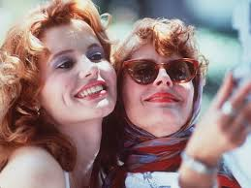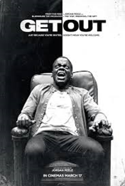

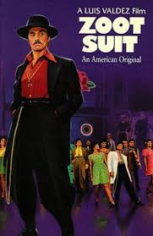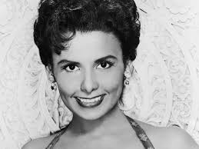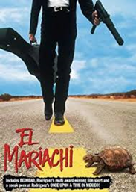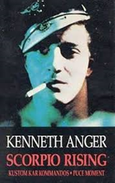

**Theatre 630 B (3 hrs.)**

**Enter 11224 in your cart**

Instructor: Shannon Blake Skelton (sbskelton@ksu.edu)

**Dates: June 10 – July 5th**

**Days: MTWUF 12:40 - 2:40 pm**

**Location: Nichols 127**

Topics Include: Silent Film, Animation Genre Theory, Golden Age of Hollywood, Critical Theory, Musicals, Queer Cinema, Feminist Film, Experimental Cinema, Science Fiction and Fantasy, Film Noir, Comedy, African-American Cinema, Sound, Montage, Acting Styles, Screenwriting and Cinematography