Master Classes with Jane Hawley
Exploring Movement Fundamentals

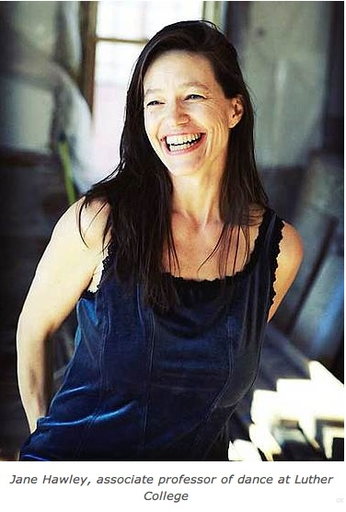
Tuesday, April 29, 2014

8:05 – 9:15 a.m.
9:30 – 10:45 a.m.
11:30 a.m. – 12:45 p.m.

Open to all students
Especially beneficial to visual artists, dancers, actors, singers, and instrumentalists

Attend 1, 2, or 3 classes

Studio Nichols 008

Discover new ways to perceive, learn, understand and train the moving artist
in technique, composition, and performance.

Jane Hawley is Professor of Dance at Luther College, and founder of

Movement Fundamentals: Liberating Practices for the Dance Artist http://www.movementfundamentals.us/

Movement Fundamentals Paradigm: http://www.luther.edu/theatredance/movement/paradigm/

For more information or questions contact: Julie Pentz jpentz@k-state.edu or Laura Donnelly, 520-784-3456, lauradonnelly@k-state.edu

